Ideation Phase: Brainstorming & Idea Prioritization
An employee requests installation of licensed software through the Service Catalog
Date | 3-09-2026
Team ID | SWUID2026190351
Project Name | An employee requests installation of licensed software through the Service Catalog.
Maximum Marks | 4 Marks

1. Brainstorming & Prioritization Overview
Brainstorming provides an open and creative environment for team members to collaborate and formulate out-of-the-box solutions. For our project—ServiceNow Employee Software Request & Automated Installation Portal—the primary goal is to transition from manual, slow IT ticketing to an automated, self-service software deployment ecosystem. This document outlines the step-by-step ideation process, from defining the Problem Statement to thematic grouping and feasibility prioritization.

2. Step 1: Team Gathering & Problem Statement Selection
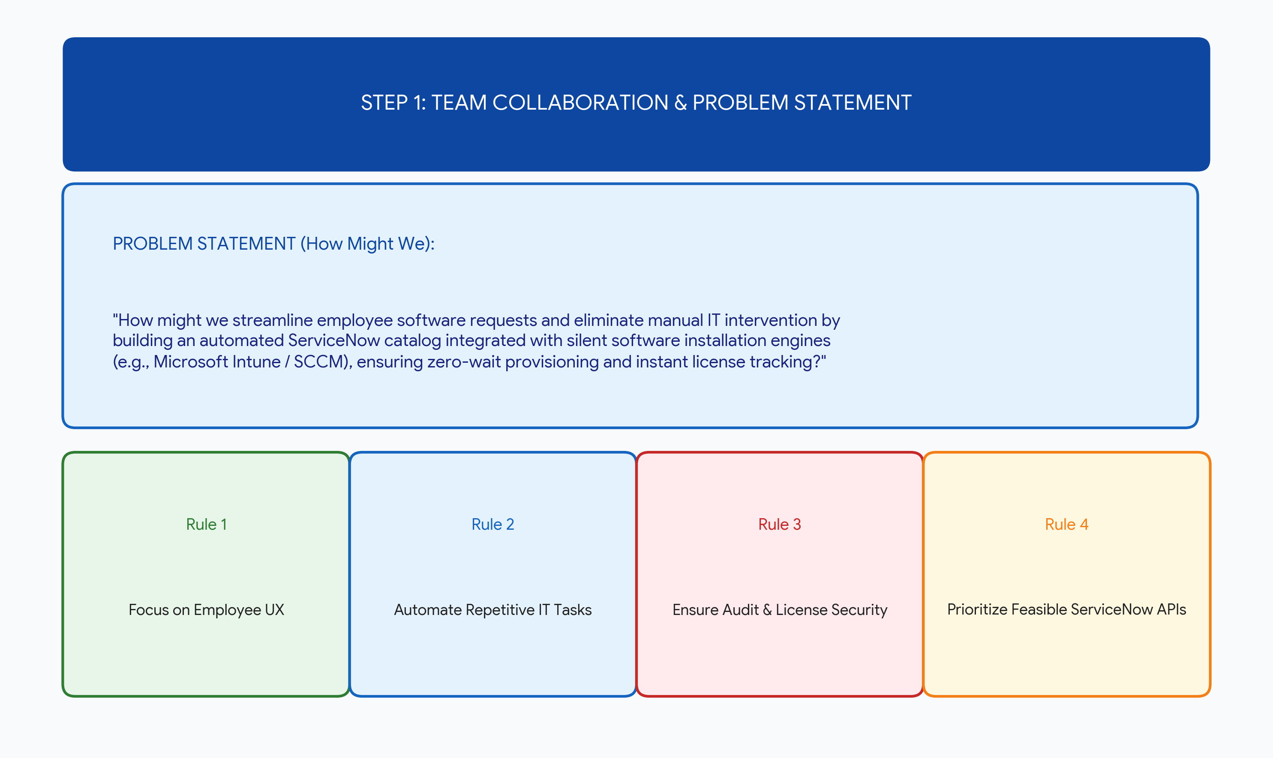
Key Guidelines Adopted During Collaboration:
• Focus on End-User Experience: Make software requesting as simple as a 1-click e-commerce checkout.
• Eliminate IT Overhead: Automate repetitive software deployment tasks using background scripts.
• Ensure Compliance & Security: Real-time license entitlement checks to avoid audit fines.
• Feasibility Alignment: Utilize native ServiceNow APIs and Microsoft Intune integration.

3. Step 2: Brainstorming, Idea Listing & Grouping
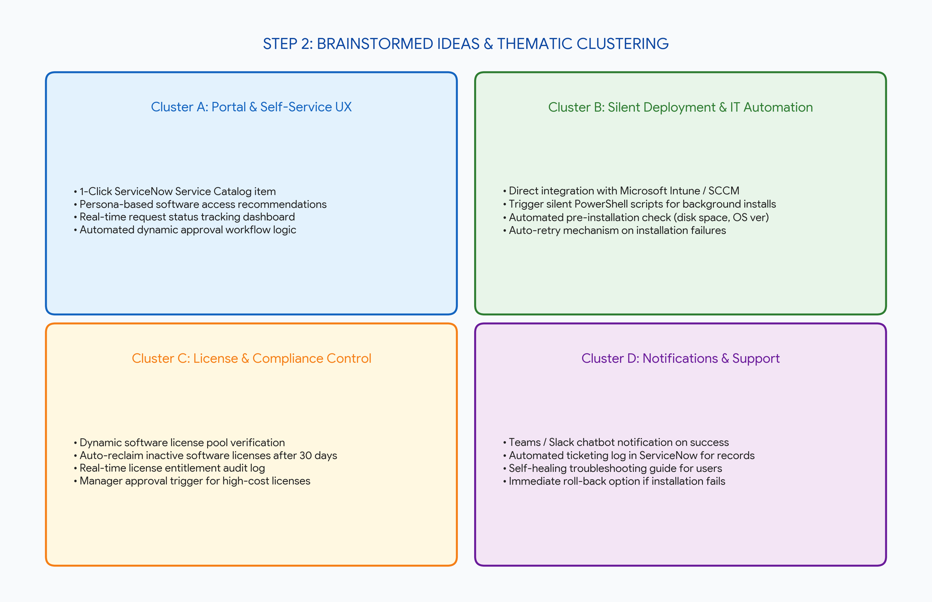
During the ideation session, team members generated multiple concepts which were clustered into 4 key operational themes:
Thematic Cluster | Brainstormed Feature Concepts
Cluster A: Self-Service Portal UX | • 1-Click ServiceNow catalog item  • Dynamic approval routing  • Real-time installation progress tracker
Cluster B: Silent Deployment & IT Automation | • Intune/SCCM API integration  • Silent PowerShell background execution  • Pre-install system requirement checks
Cluster C: License & Audit Governance | • Automated license pool verification  • Auto-reclaim inactive licenses after 30 days  • Entitlement audit log generation
Cluster D: Notifications & Incident Recovery | • Microsoft Teams / Slack bot instant alerts  • Automated ticketing log in ServiceNow  • Self-healing roll-back on deployment failure

4. Step 3: Idea Prioritization Grid (Impact vs Feasibility)
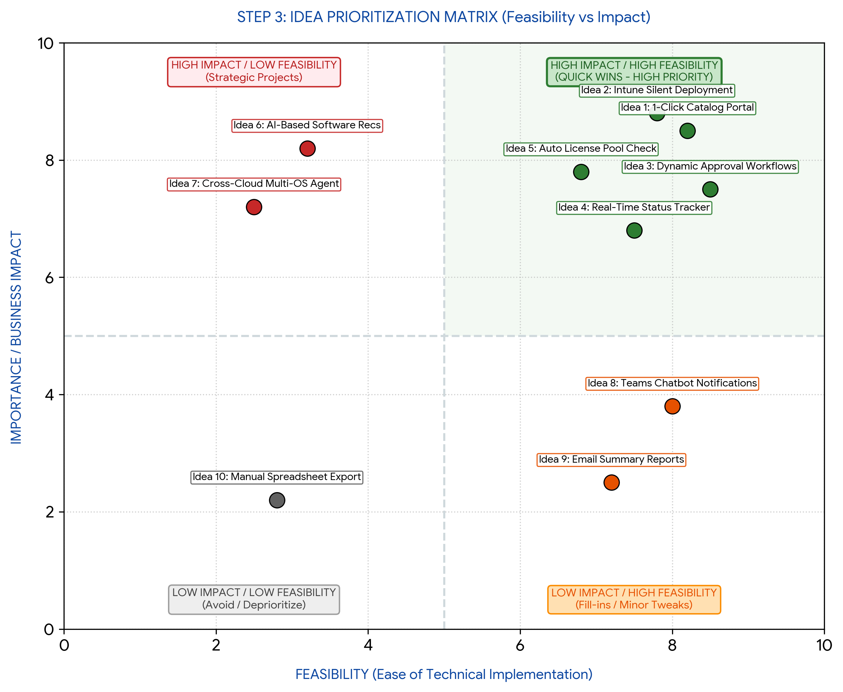
To determine which features to include in the initial project release (MVP), ideas were plotted on a 2x2 Feasibility vs Impact Grid:
• High Impact & High Feasibility (Quick Wins): 1-Click Catalog Portal, Intune Integration, Dynamic Approvals, Real-time Tracker, Auto License Pool Check.
• High Impact & Low Feasibility (Future Strategic): AI-based Software Recommendation Engine, Cross-Cloud Multi-OS Agent.
• Low Impact & High Feasibility (Secondary Add-ons): Microsoft Teams Chatbot Notifications, Email Summaries.
• Low Impact & Low Feasibility (Discarded): Manual Spreadsheet Licensing Export.

